(Trading Simulator)

Setup and Functional Document

Prepared by

**Hema Gandhi / Rushikesh Teli / Shital Patil**

Tuesday, December 08, 2015

**Version 1.0**Document Control:

|  |  |  |  |  |
| --- | --- | --- | --- | --- |
| **Security Classification:** | IGATE Internal Confidential | | | |
| **Issue Date:** | 3rd December 2015 | | | |
| **Author(s):** | **Name** | **Title** | | |
| Rushikesh Teli | Technical Specialist | | |
| Shital Patil | Technical Lead | | |
| **Reviewer(s):** | **Name** | **Title** | | |
| Hema Gandhi | Associate Director | | |
| **Distribution:** | **Name** | **Company** | | |
|  |  | | |
|  |  | | |
| **Document History:** | **Date** | | **Revision Change** | |
| 3rd December 2015 | | 1.0 | Initial Draft |
|  | |  |  |

Table of Contents

1 Introduction 4

2 Application Functionality 4

2.1 Features 4

2.2 Technologies 5

2.3 Technical Pre-requisites for setup and running the application 5

3 Training Section 5

3.1 Add New Topic 6

3.2 Update a Topic 8

3.3 Delete a Topic 8

4 Application Section 8

4.1 Registration Screen 8

4.2 Login Screen 11

4.3 Home Page 11

4.4 Buy / Sell Screen 12

4.5 Order Book 15

4.6 Trade Book 15

4.7 Quotes 18

# Introduction

This document aims at creation of a simulator which will provide a glimpse into the intricacies of the trading solutions. The application features can be developed in step wise manner. The application consists of two main parts/sections

* Training Section: This part of application mainly covers a training section, which is audio visual training.
* Demo Application: This is completely front end based application where one can try Trading Simulation on local machine.

1. The first phase covers basic requirements such as a User Registration, Login, news section having set of dummy news to simulate real life market news, trade price banner which get live trade values from yahoo API, Buy/Sell of predefined stocks, Order Book, Trade Book and portfolio. This phase will deal with common predefined stock only.
2. Further phases may build on these foundations and will entirely depend on the need to train the resource on varied services.

# Application Functionality

## Features

|  |  |  |
| --- | --- | --- |
| **Sr. No.** | **Feature** | **Details** |
| 1. | Allows user to enter registration details with basic fields | * Registration is real but storage in on browser local storage |
| 2. | Allow registered user to login | * All the Login ID’s will be created during registration and same can be used only on same machine as long as browsers local storage is intact |
| 3. | Home Page with gist of portfolio, order and useful information | * Home Page contains * Portfolio, Order Status, Trade Book * Live Stock Prices for predefined stocks * Dummy News, Exchange graph * Actual Positions count |
| 4. | Buy / Sell Stocks | * Users can buy / sell set of predefined stocks at predefined value and his positions would get updated accordingly |
| 5. | Order Book | * This will show all unsettled trades which are in pending state |
| 6. | Trade Book | * This section will show all settled transactions |
| 7. | Quotes | * This is dummy page that shows what all data is fetched in quotes |

## Technologies

* HTML
* Twitter BootStrap3.0
* AngularJS
* JQuery
* NodeJS (Only Web Server)
* Bower (Only Package Manager)

## Technical Pre-requisites for setup and running the application

* For Development one needs to have NodeJS and Bower setup on local. As all front end packages are managed by bower, we used node for web server only.
* To Install node: Please refer instructions on <https://nodejs.org/en/download/>
* Run the command “npm install -g bower” to install bower globally on your machine. Bower depends on Node.js and npm. Also make sure that git is installed as some bower packages require it to be fetched and installed.
* One needs to have HTML editor i.e. Open Source Brackets / Sublime Text for development as it eases the front end development.
* AngularJS is not supported by older browser versions, so **in order to run the application one needs to have latest browsers that supports AngularJS.**
* To start the application, specify host and port in package.json and hit command as shown in below code snippet. The value of host and port can be specified in start command with –a and –p option respectively.

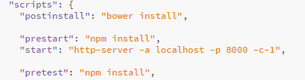

>npm start

This command will install all dependencies and start the node web server

# Training Section

Once you hit URL <http://localhost:8000/app/#/demos> (host and port may vary depending on where it’s hosted as mentioned above.

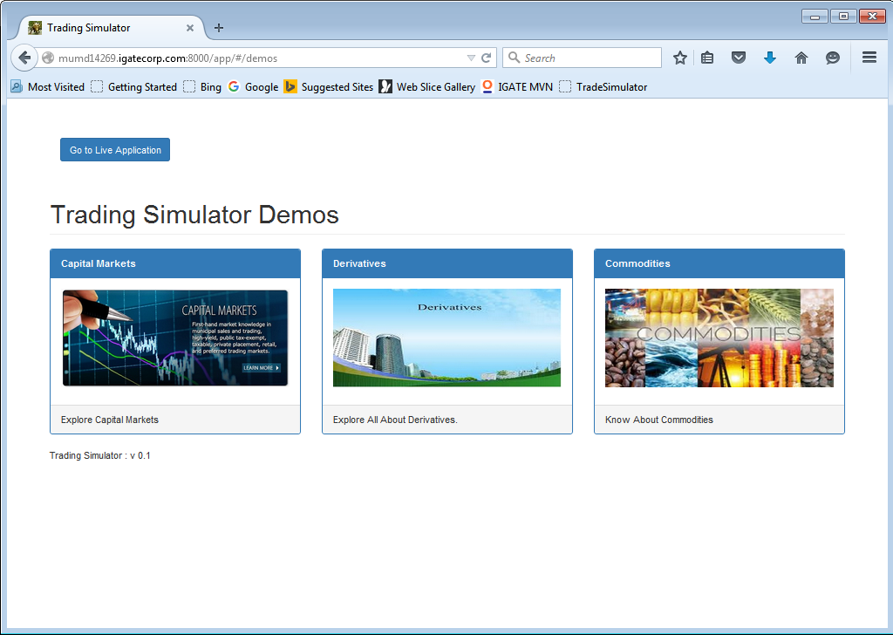

Demo’s section mainly consists of training topics listed. i.e. in above case

* Capital Markets
* Derivatives
* Commodities

These trainings are audio visual and one need to add images and corresponding videos in mp3 format. You can add / update / delete topics just by configuration change in code. No coding required.

## Add New Topic

* One has to modify file namely app\demotopics\topiclist.json and add JSON

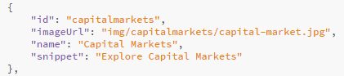

Id: URL you want to keep

imageURL: Name of Banner URL

name: Name at the top

snippet: Text below the banner image

* One needs to add images and title to be displayed in section in JSON file and place that file under demotopics

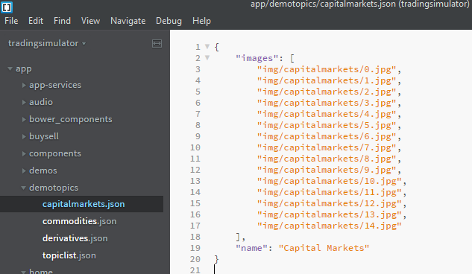

* Also one needs to add images (.jpg extension only) and mp3 audio under corresponding folder i.e. for capitalmarkets

Images under “app\img\capitalmarkets”

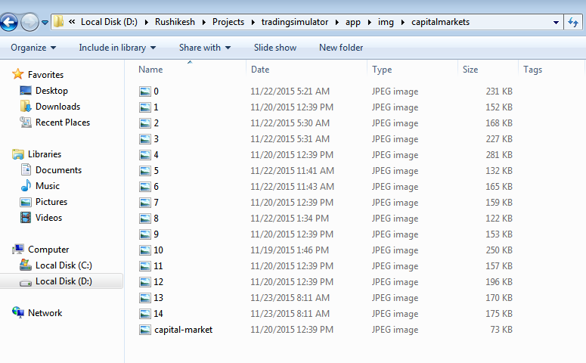

Audio files under “app\audio\capitalmarkets”

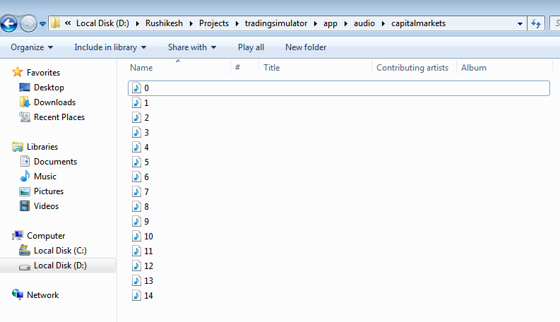

Please note that files should be named as 0 …. 10 …. 20 etc as the logic to play mp3 audio for corresponding image is based on same file names for audio and image. i.e. for 0.jpg the audio file 0.mp3 will play

You can skip to have audio for particular file by skipping that file name.

## Update a Topic

Refer documentation for add topic. One can always modify topic by adding deleting the slides. Just make sure that image and audio mapping is maintained.

## Delete a Topic

Simply delete the topic name from “app\demotopics\topiclist.json” and that topic will not be displayed on landing page of demo.

# Application Section

## Registration Screen

New User can register them using registration screen. One can go here from login page or by directly hitting URL <http://mumd14269.igatecorp.com:8000/app/#/register>

All Fields are mandatory and that’s only validation as it’s a simulator application. One can enter First Name, Last Name, User Name and Password and get registered through this screen.

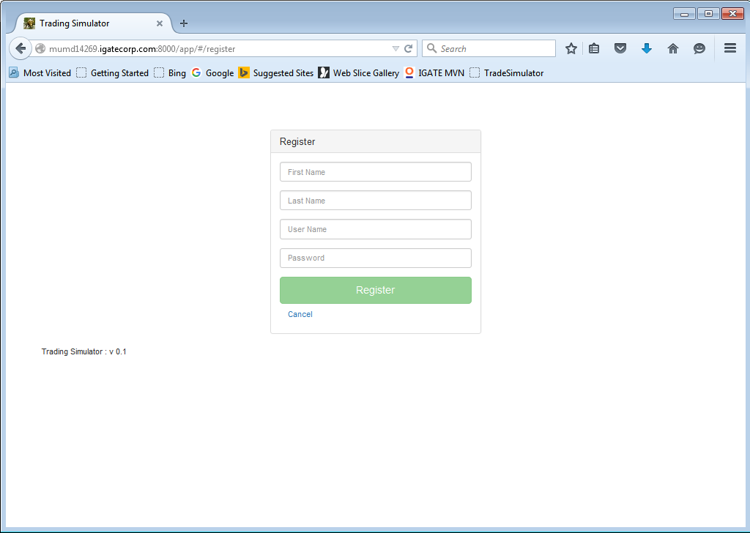

Exercise:

Create 2 users namely with username as user1 and user2 respectively. You can have 121212 as common password for sake of simplicity.

On registration screen enter details as shown below and click on “Register” button.

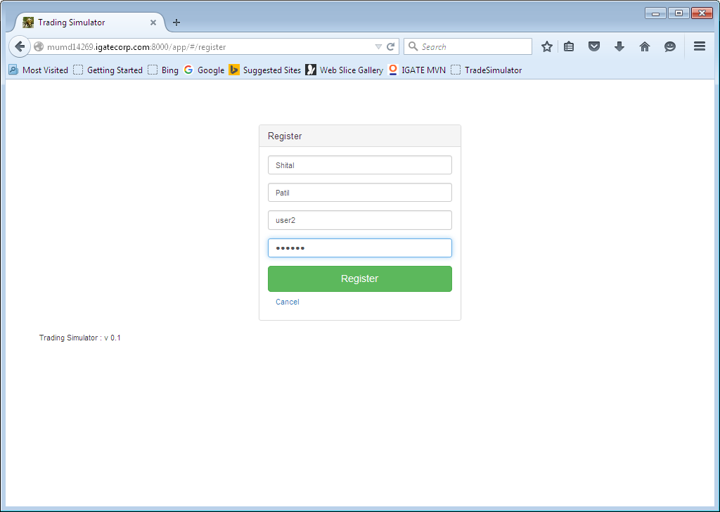

User will get confirmation message with login screen as shown below.

Similarly create another user. One needs at least 2 users to try out all functionality of trading simulator.

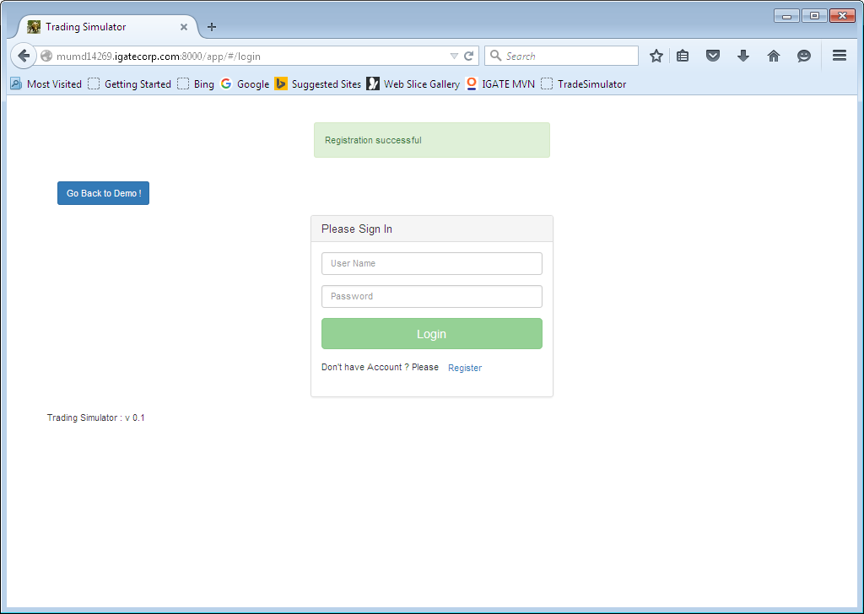

## Login Screen

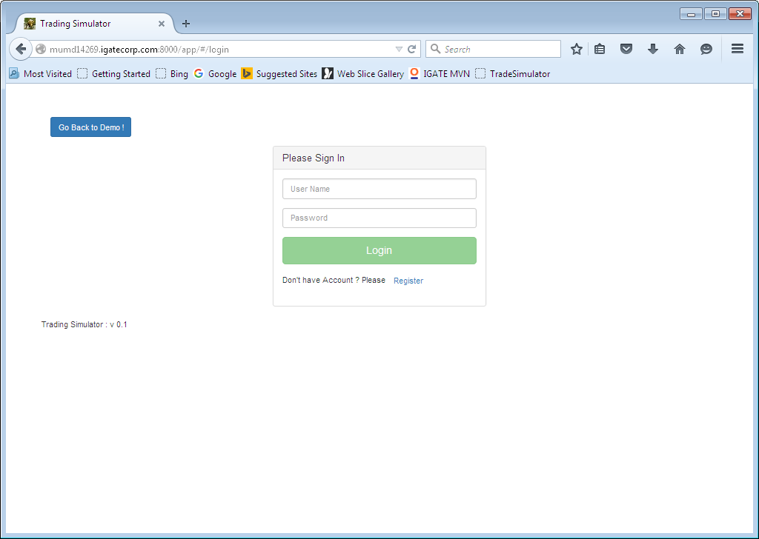

One can enter username and password used for registration and login to application

## Home Page

A fresh screen for logged in user will look like as shown below. Home screen has following

* Moving Banner with live stock prices for predefined companies is displayed on top.
* There are 4 widgets for
  + Buy/Sell: This shows total number of trade orders. It’s a sum of Pending and Executed orders.
  + Order Status: This widget shows total number of pending orders.
  + Trade value: Currently it’s a fixed dummy value net sum of buy and sell trades.
  + Portfolio: Currently it’s a fixed dummy value.
* It will have Sensex Graph, Positions Summary and News Feed (Dummy Data).
* Top Navigation Bar, having links to various features.

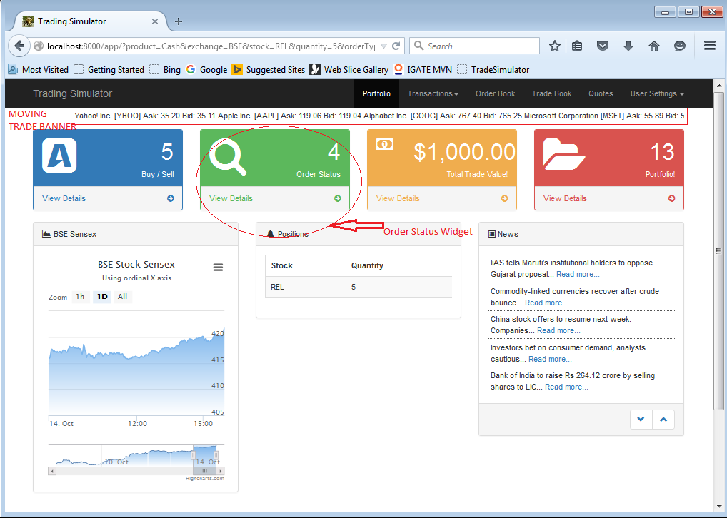

## Buy / Sell Screen

One can navigate to buy/sell screen from top navigation bar OR from “Buy/Sell” widget shown on home screen. This is the screen where user can buy or sell his stocks.

There are 2 tabs for buy and sell feature.

The screen looks like as shown below.

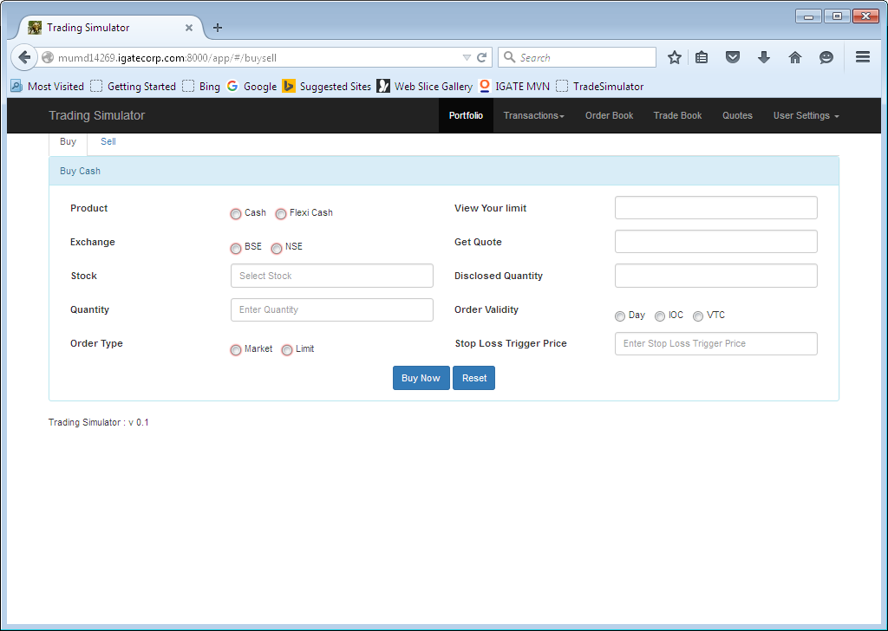

The screen has some basic validation so one has to enter some basic data to execute buy / sell transaction.

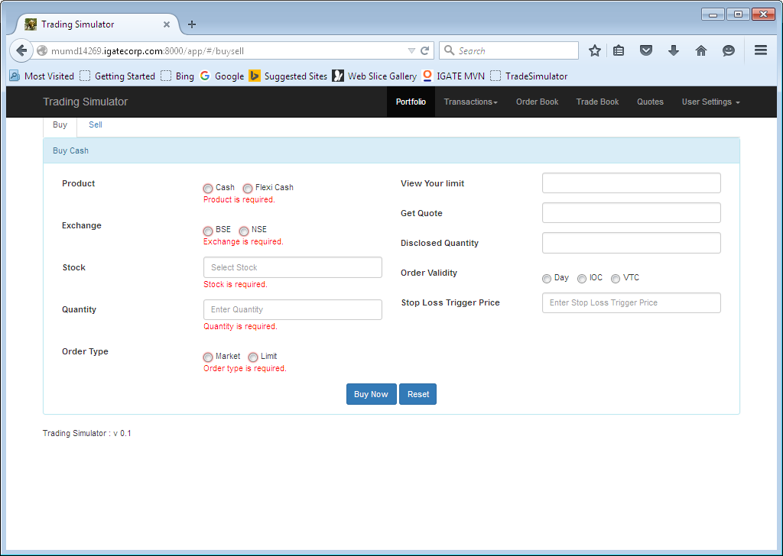

Exercise:

Log in with user1 and purchase 3 4 stocks as shown below.

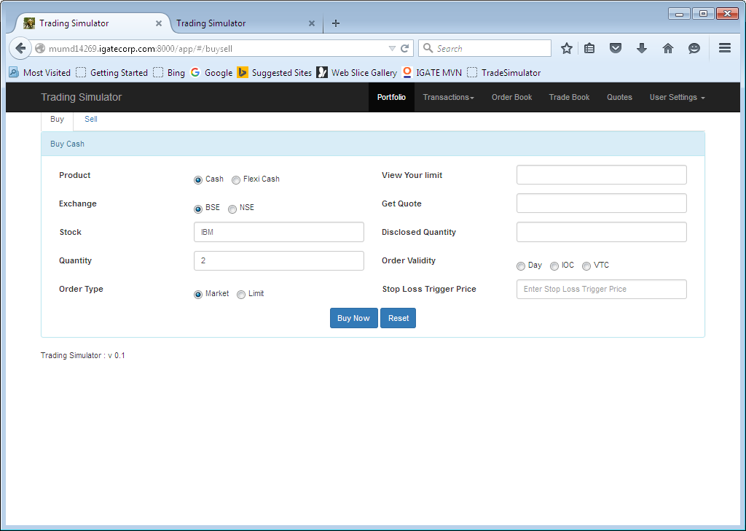

You will get a confirmation screen

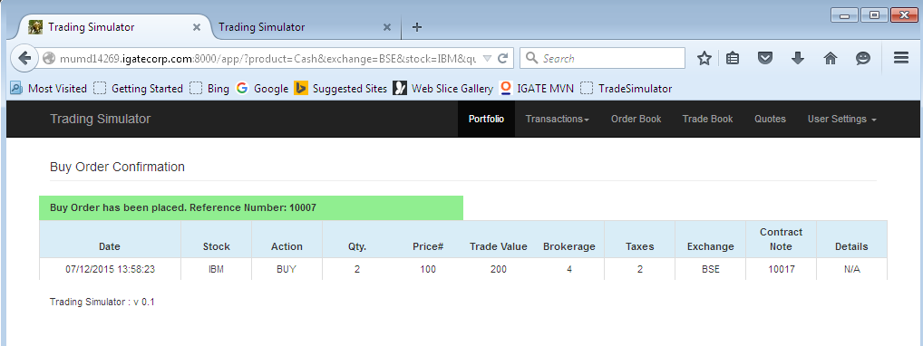

Also make sure that entry goes to order book as shown in order book section Diagram 1.

Similarly buy another 3 4 stocks from user 1. You can also do separate buy transaction of same stock with different quantity.

## Order Book

**Diagram1:**

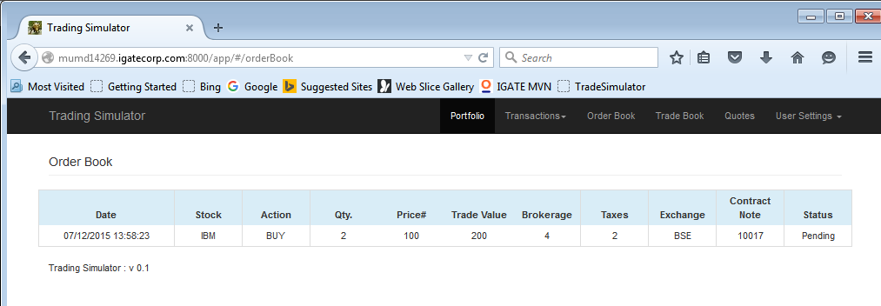

**Diagram2:**

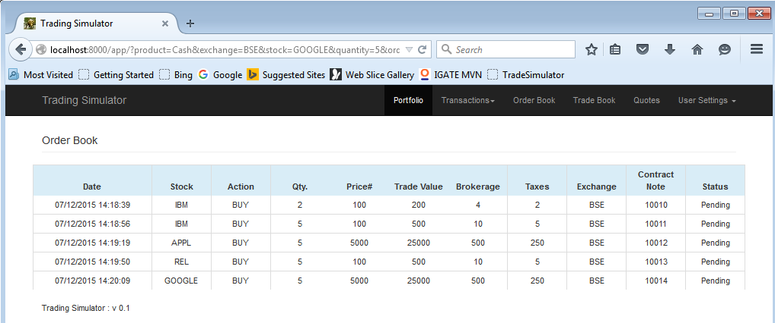

## Trade Book

Trade book will show entry for executed trades. In order to see what goes in Trade book login through another user “user2” and perform sell transaction that matches quantity and price of one of the buy trades of “user1”

In trade simulator application matching logic is purely based on stock code, quantity and price.

Exercise:

Login with “user2” and perform sell transaction. i.e. Sell 2 trades of Reliance as shown below

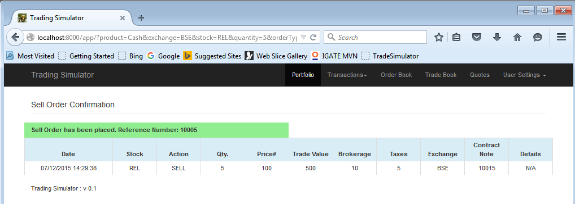

Now the order book will show empty 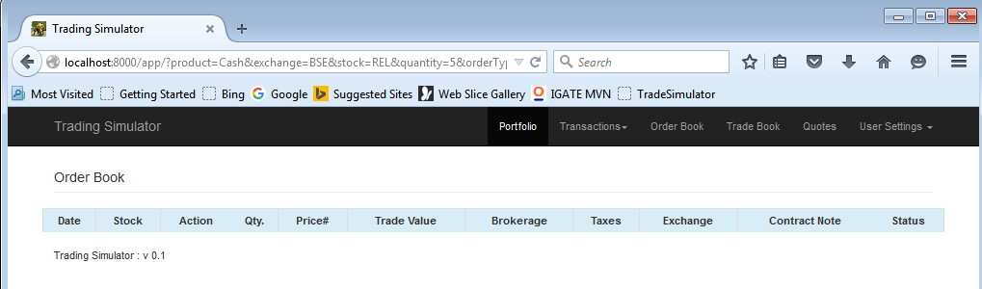

**Trade book will show executed trade**

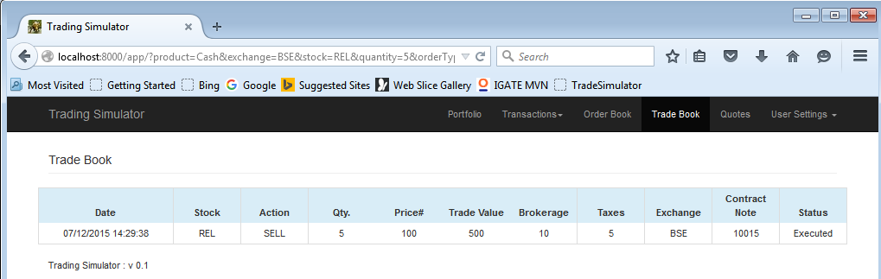

Now if you log in with user1 then order book will not show buy entry of matching trade but trade book will show executed BUY trade as shown below and home screen will show updated positions

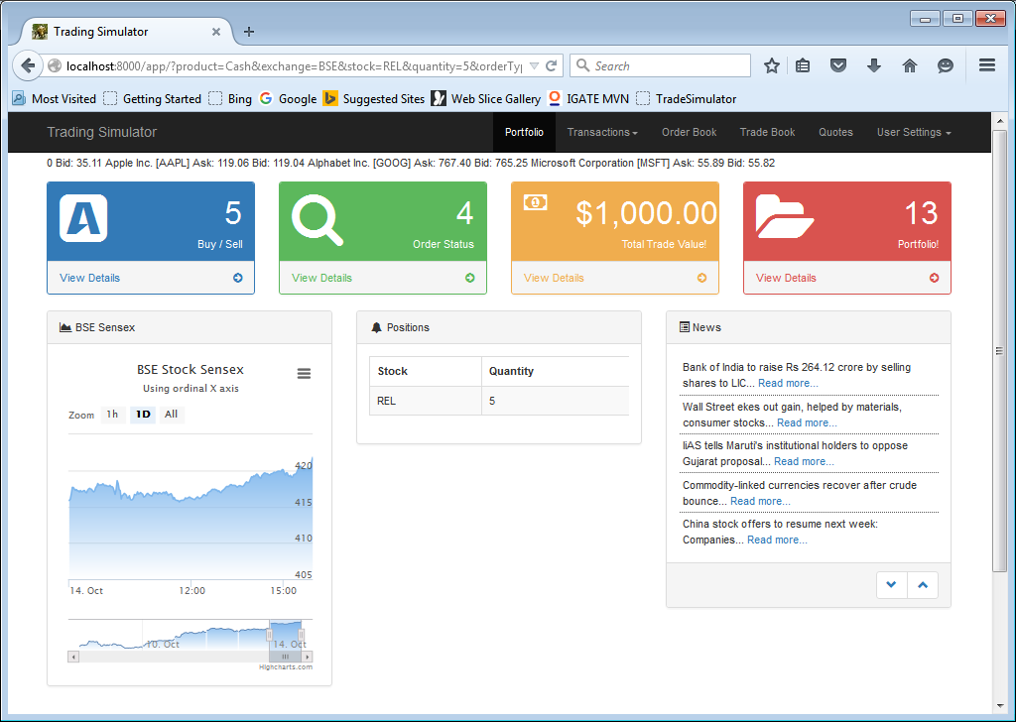

Order Book doesn’t have Reliance Entry as trade is executed.

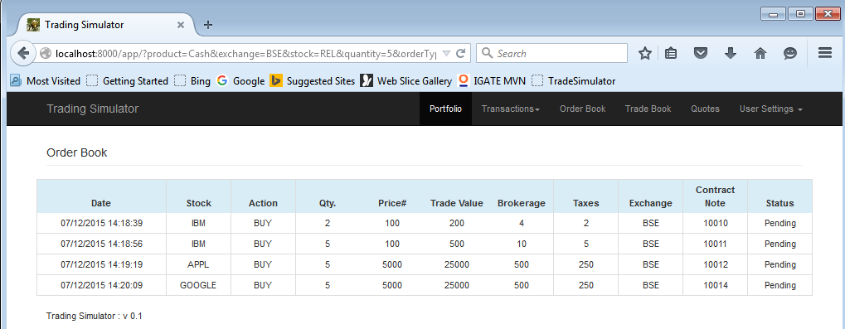

Trade Book shows Reliance Entry as trade is executed.

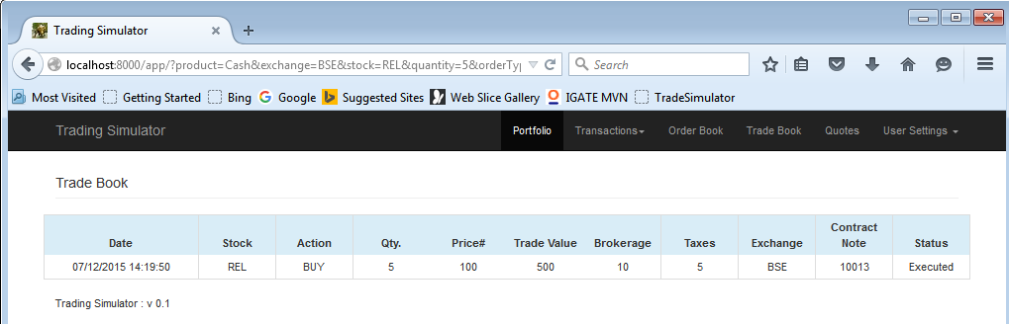

## Quotes

Quotes Page shows sample screen about what all data is fetched when we want to get quote for any stock.

